##### 

# 

# VIRGINIA ALCOHOLIC BEVERAGE CONTROL

# BUREAU OF LAW ENFORCEMENT

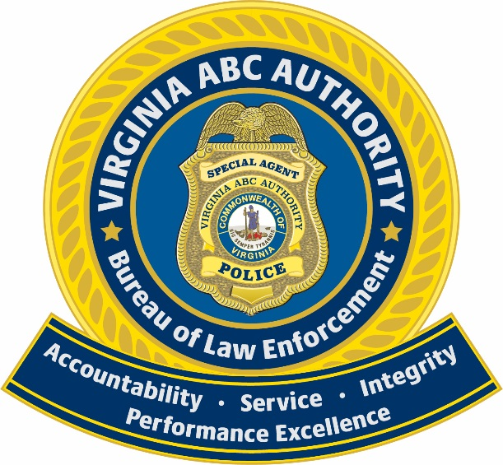

QUARTERLY REPORT

4th Quarter - 2023

October 1st through December 31st

**CONTENT**

Subject Page

Executive Summary 2

Arrests 3

Regulatory Violations 5

Field Contacts 6

Planned Operations Executed 7

Use of Force Incidents 7

Internal Investigations 8

License Activity 9

Inspections 10

Observations 10

Underage Buyer Programs 11

Training 12

Accreditation 13

Executive Summary

The Governor’s Expert Panel gave clear directions on the content of this quarterly report. This report follows those basic guidelines. Listed below is a synopsis of the data reported in each of those areas:

1. **Criminal Violations** – There were 108 charges placed this quarter with 103 (95%) charges related to alcohol violations. Last quarter there were 213 charges placed with 120 (56%) charges being alcohol related. Arrests are down 49% compared to last quarter.
2. **Regulatory violations** – This quarter saw a 124% increase in violations brought to hearings and an 20% increase in written warnings when compared to 3Q 2023. There was an 9% decrease in regulatory charges adjudicated in hearings with 182 in 3Q 2023 and 166 in 4Q 2023.
3. **Field Contacts** – There were no field contacts made this quarter.
4. **Planned Operations –** There were 7 planned Operations – 4 were controlled and run by VA ABC Bureau of Enforcement and three were assisting local law enforcement agencies.
5. **Use of Force Reports** – There were no reported Use of Force incidents this quarter.
6. **Internal Investigations** – There is currently one open Internal Investigations. There were no informal complaints assigned to the field.
7. **License Activity** – Retail approvals are increased 19% for the fourth quarter of 2023 compared to the previous quarter. Retail license approvals are up 18% when compared to the fourth quarter of 2022. Banquet license approvals show a 25% decrease when compared to the previous quarter and a 9% increase when compared to the fourth quarter of 2022.
8. **Inspections/Observations** – Inspections showed an increase of 57% when comparing fourth quarter of 2023 to third quarter of 2023, and a 1% increase when compared to the fourth quarter of 2022. Observations are up 16% when comparing fourth quarter 2023 to the previous quarter.
9. **Underage Buyer –**There were 883 Alcohol checks made and 11 Tobacco checks. The compliance rate for all Alcohol checks for the quarter is 89% and the compliance rate for Tobacco checks is 64%. Last quarter the compliance rate for Alcohol checks was 87% and for Tobacco checks it was 87%.
10. **Training and Community Outreach** – ABC presented over 908 hours of training to law enforcement, licensees, and the general public this quarter. This included MART, RSVP, and training conducted during initial on-site inspections. There were 581 hours of training received by ABC agents. These agents also attended over 728 hours of community outreach meetings.
11. **Accreditation** – The Virginia ABC Authority Bureau of Law Enforcement (BLE) is a State Accredited Law Enforcement Agency under the authority of the Virginia Law Enforcement Professional Standards Commission, (VLEPSC) . BLE is currently in the process of VLEPSC re-accreditation for its third award. An assessment was conducted on November 14th and 15th of 2023 reviewing a total of 190 standards that must be met for each term of the four-year accreditation cycle, with numerous proofs required for each standard. BLE had zero returns during this assessment and hopes to receive the final award from the Board in March of 2024. In the interim, BLE has begun a new re-accreditation term which began on November 1, 2023 and will end on October 31 , 2027.

Most of the above data will be broken down by region. The map below outlines Virginia by region:

Region 1-Roanoke, Region 2-Lynchburg, Region 3-Stauanton, Region 4-Alexandria, Region 5-Fredricksburg, Region 6-Richmond, Region 7-Hampton,

Region 8-Chesapeake, Region 9-Charlottesville

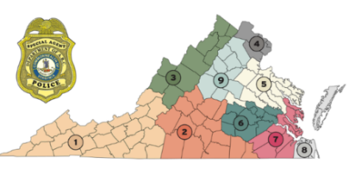

Arrests

**Criminal Charges**

This table reflects the total and type of criminal charges that were placed by ABC enforcement personnel between October 1st through December 31st (fourth quarter 2023), and totals for the year.



* *The charges of larceny, shoplifting, embezzlement, and fraud are primarily related to our retail stores.*



**Arrests by Region**

This table breaks down the total criminal arrests - by region where the offense took place, comparing the percentage change from arrests in the third quarter of 2023 to arrests in the fourth quarter of 2023 and total for the year.

**Note:** These are arrest figures involving the three types of reportable arrests; In-custody, Released on a Summons and Warrant. These numbers may differ from the number of charges placed by ABC Enforcement.



**Arrest by Type and Race**

This table reflects the race of arrested individuals in the fourth quarter of 2023. The data is broken down into the three types of arrests (On-View - Taken into Custody, Released on a Summons and Warrant - Taken Into Custody)



**Arrest by Age and Gender**

This table reflects a breakdown by gender and age of all adults that have been arrested in the fourth quarter of 2023. This includes all types of arrests - (in-custody, released on summons and warrant).



Regulatory Violations

A large portion of the work performed by Virginia ABC Special Agents involves the enforcement of rules and regulations applicable to ABC licensees. Violations can be dealt with by issuing a written warning or by presenting a violation case to the ABC Hearings Division. These violations can be punishable by fines, suspension, or revocation of the ABC license.

**Regulatory Charges Placed by Region**

This table represents the total number of regulatory actions that were placed by enforcement personnel in the fourth quarter of 2023. Violations were routed to the hearings division for later adjudication while warnings were noted in the licensee file.



*\*Count of individual charges*

*\*\*License Records Management consists of system-generated warnings for late MBAR violations.*

**Regulatory Charges Adjudicated in Hearings**

This table represents the total number and type of charges that were adjudicated by the ABC hearings division in this quarter as a result of the regulatory charges previously placed by ABC agents.

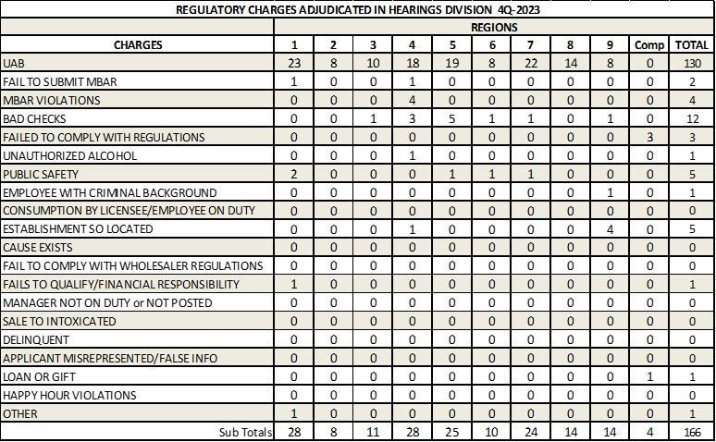

Field Contacts

A field contact is when an agent engages a citizen and conducts a brief interview. When an arrest does not occur as a result of a field interview, agents report the stop in a “Field Contact” report. This report documents the reason for the stop as well as identifying information about the individual. Scrutiny of these types of encounters enables law enforcement executives as well as citizens to monitor police/citizen interactions to guard against biased-based policing practices.



Planned Operations Executed

An “Operational Plan” is submitted for all structured, pre-planned operations/observations for which enforcement action is anticipated, (i.e.: any undercover operation, most search warrant executions, and any enforcement operation involving five (5) or more sworn personnel), prior to any Bureau sponsored special event, or where Bureau personnel are utilized by an outside agency for undercover activity.

This table is a summary of the planned operations that took place in the fourth quarter of 2023.



|  |
| --- |
| SAC – Special Agent in Charge |
| ASAC – Assistant Special Agent in Charge |
| SSA – Senior Special Agent |
| SA – Special Agent |

Use of Force Incidents

The Bureau considers any amount of effort required by an agent to compel compliance by an unwilling subject that exceeds normal restraint or handcuffing to be a “Use of Force;” which requires a supervisor be notified and a Use of Force report completed.



Internal Investigations

Any complaint alleging improper action or improper conduct by an employee, if job-related or in violation of the Standards of Conduct, other policies of the Bureau, Department of Human Resource Management, the ABC Policy and Procedures Manual, or criminal law, will generate an administrative internal investigation. There are two types of internal investigations that are conducted by the Bureau; Formal and Informal (the difference is explained below). Both types of investigations are documented and reported through the chain of command.

**Formal Complaint(s)**

Formal complaints involve allegations that are investigated by trained Internal Affairs investigators and, if substantiated, can lead to formal and significant disciplinary action.



**Informal Complaint(s)**

Informal complaints are minor allegations of infractions investigated by mid-level regional supervisors and the complainant is satisfied with the resolution offered and only wishes the matter to be handled informally by the supervisor.

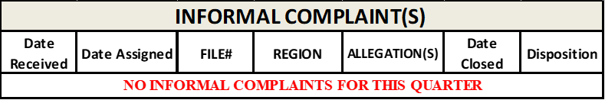

License Activity Totals

A significant amount of an agent’s time is committed to the approval process of both retail and “one day” banquet licenses. This process involves background investigations, venue/establishment inspections and training.

**Retail License Approvals**

# Retail Application approvals, sometimes tied to economic conditions, increased 19% for the fourth quarter of 2023 when compared to the previous quarter. In 4Q of 2022 there were 476 retail license approvals compared to 563 in 4Q of 2023 reflecting a 18% increase in approvals.



**Banquet Licenses Approvals**

Banquet License approvals, which follow seasonal trends, decreased 25% in the third quarter when compared to the previous quarter. In 4Q of 2022 there were 4510 banquet license approvals compared to 4932 in 4Q of 2023 reflecting a 9% increase in activity compared to the third quarter of the previous year.



**Total Retail Licenses**

Total Retail Licenses in the state has shown steady incremental growth.

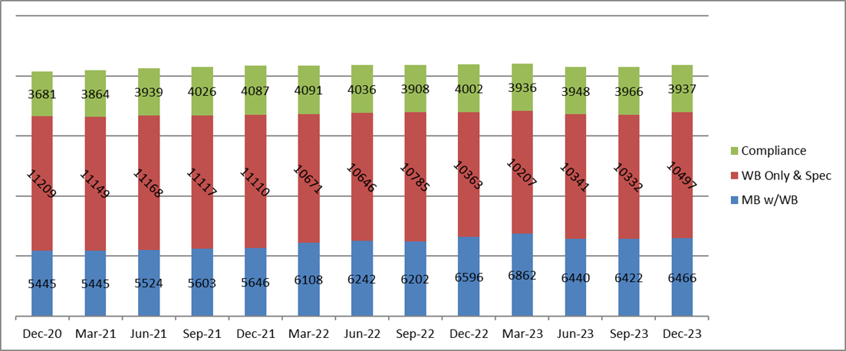

Inspections / Observations

**Licensee Inspections Completed**

All ABC licensed establishments are subject to inspection by ABC agents. These inspections are overt; the agent will inspect the premises for compliance with regulatory requirements, meet with the owner or manager to review business receipts and purchasing records, review previously submitted MBARs and answer any questions business employees may have about ABC laws and requirements.



**Records system only allows for a snapshot of the total license count. Total licenses do not include 1804 out-of-state licenses. License totals include Wine & Beer Off Premise Licensees which are only inspected every two years, thus the percentage of licensees inspected is not expected to be 100% for a one-year cycle.

**Observations Completed**

Agents also conduct unannounced, covert, plain-clothes observations of ABC establishments to ensure licensees are following all ABC laws and regulations. Many of these observations are follow-up investigations initiated by citizen complaints.



Underage Buyer Totals

The Underage Buyer (UAB) program is an ongoing effort by Virginia ABC to visit alcohol and tobacco retailers throughout the Commonwealth to verify compliance with the state age requirements which are 21 for tobacco and 21 for alcohol sales. Special Agents accompany underage operatives during attempts to purchase cigarettes or alcohol at grocery stores, convenience stores, restaurants, and other businesses, including Virginia ABC stores.

**Underage Buyer Program Checks – Alcohol**



**Underage Buyer Program Checks – Tobacco**



Training

Virginia ABC Enforcement is committed to continuously improving the knowledge base and understanding of our Agents, our fellow law enforcement agencies, our licensees, and the community. To this end, this quarter agents presented over 908 hours of training to law enforcement, licensees, and the general public. Of the 581 hours of training instructed for licensees, 480 hours were conducted during site visits and 53 hours for MART and RSVP training. There were 581 hours of training received by ABC agents this quarter. These agents also attended over 728 hours of community outreach meetings.



Accreditation

The Virginia ABC Authority Bureau of Law Enforcement (BLE) is a State Accredited Law Enforcement Agency under the authority of the Virginia Law Enforcement Professional Standards Commission, (VLEPSC). BLE is currently in the process of VLEPSC re-accreditation for its third award. An assessment was conducted on November 14th and 15th of 2023 reviewing a total of 190 standards that must be met for each term of the four-year accreditation cycle, with numerous proofs required for each standard. BLE had zero returns during this assessment and hopes to receive the final award from the Board in March of 2024. In the interim, BLE has begun a new re-accreditation term which began on November 1, 2023 and will end on October 31 , 2027.

